**SWITCHING THE BULB USING A KEYPAD**

**ABSTRACT**

This project is about a technology of switching a bulb by using a keypad. In the actual and daily life we need lights for lightning our houses, hospitals, hotels…

This project will provide a security service of lightning where can be used for examples for the hotels and other places where people meet in order to decrease wastage of energy. By using a keypad to turn on and off the lamps, it will need a password to turn on and off the lamps so that for example for the management of the place can manage the amount of electricity to be used through lamps because you can use a code that can’t be used by anyone else except you. An LCD display will help to display the codes or passwords while typing it and helps to show you whether is correct or wrong. the project will also need an Arduino to perform the role of the codes of the circuit.

**PROBLEM STATEMENT**

It is a fact that everyone needs security of his own things and people likes when they have the full access on their own things that’s why we host this project to work on security problems seen when we don’t have lights. A thief at night when there are no lights he enters easily in the house and do harm things to people In the house but as we live in a smart life now, by using this system it won’t be easy for the thief to turn off the lights because the code in the keypad will be only known by the owner. The system also can be used in special rooms or security rooms so that to enter in it you will need the code in the keypad to turn on and off the lights because we all know that nothing can be done when we have no lights.

**CIRCUIT DIAGRAM**

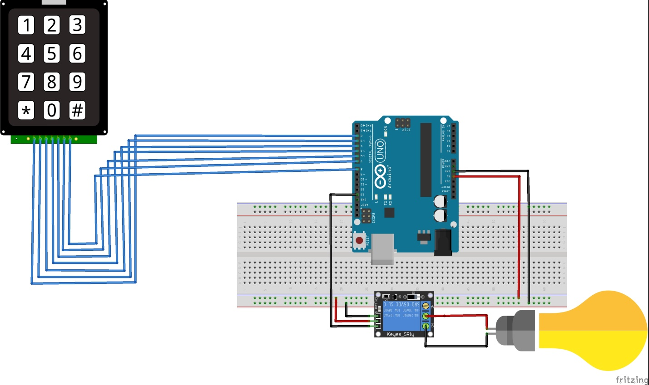

**DISCRIPTION**

**Arduino uno**: Arduino uno microcontroller can sense the environment by receiving input from a variety of sensors and can affect its surroundings by **controlling lights, motors, and other actuators as we will use it to control light**

**Lamp: is used for lightning**

**Relay:** A relay is an electromagnetic switch**operated by a relatively small electric current that can turn on or off a much larger electric current**

**Keypad:** A keypad is a block or pad of buttons**set with an arrangement of digits, symbols, or alphabetical letters. Which will be used set a password of switching on the lamp in our project.**

**SIMILATION IN PROTEUS**

